Project: Supply Pricing & Inventory Exchange Network

Team Contribution:
Anh - Manufacturer enterprise - Admin authentication CRUD, Product analyst, Operation Manager
Kenneth - Wholesaler enterprise - Admin authentication CRUD, Wholesaler enterprise, retailer enterprise, prepopulated faker data
Christopher - Retailer enterprise - store manager, store associate

Enterprise Admin test for all Manufacturer, Wholesaler, and Retailer:
- Manage Organizations: create new organizations of the types allowed for that enterprise; view/update an organization's name; delete an organization (blocked with a confirmation dialog).
- Manage Employees: add employees to any organization within the enterprise; view/update an employee's name.
- Manage User Accounts: create a login (username/password) for an employee and assign them one of the roles supported by their organization; view/update an account's username, password, or role.

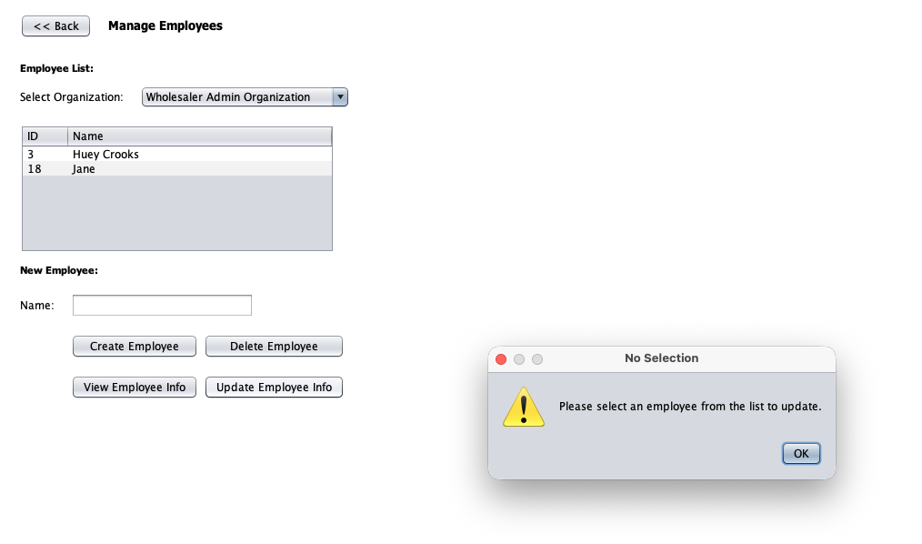
All CRUD work with warning messages pop up when there is no selection.

Manufacturer: Owns the Manufacturer Operations Organization and its two roles: Production Analyst and Operations Manager.

Product Analyst:
Submit priority request: sends an item name + message to the Operations Manager; validates the item name is not blank before allowing submission.
Claim quote request: picks up an unclaimed cross-enterprise QuoteRequest sent in by the Wholesaler Pricing Analyst. Blocked with a warning if the selected row isn't a quote request, or if it's already claimed.
Respond to Quote Request: enters a quoted price (validated as a number) and either submits it for the Wholesaler's approval or rejects the request outright. Blocked with a warning if the request hasn't been claimed first.

Operation Manager:
Assign To Me: claims a pending PriorityRequest from the Production Analyst by setting the request's receiver to the current account and its status to "Pending".
Process (Set Priority/ETA): sets a 1–5 priority level and an estimated completion date; the date field is validated against a strict MM/DD/YYYY format and rejected with a warning if it can't be parsed or is left blank; approving sets status to "Completed", rejecting sets it to "Rejected".

The work queue also surfaces completed cross-enterprise QuoteRequests as read-only notifications once the Wholesaler has approved a quote.

Wholesaler:
3 organizations: sales, pricing and marketing

Pricing Analyst
View Inventory: lists the wholesaler product catalog and lets the analyst change a product's price through an input dialog; invalid (non-numeric) prices are rejected with an error dialog rather than silently applied.
Messages from Sales: reviews PriceChangeRequests submitted by the Wholesaler Sales Rep and records an Approve/Deny verdict with an empty verdict is rejected with a warning.
Messages to Manufacturer: sends a cross-enterprise QuoteRequest to the Manufacturer's Operations organization and, once the Production Analyst has quoted a price back, approves or rejects it via a confirmation dialog and requests that haven't been quoted back yet can't be approved.

Sales Representative
View Sales Data: read-only report of orders placed by retail stores, pulled from the EcoSystem-wide WholesalerMasterOrderList.
Request Pricing Change: submits a PriceChangeRequest into the Pricing organization's queue; a blank message is rejected.
Make Marketing Request submits a MarketingRequest into the Marketing organization's queue for overstocked items.
Order Processing: wholesaler-side product catalog/ order screen.

Marketing Specialist
Marketing Requests: reviews incoming MarketingRequests and completes them by attaching a marketing-proposal file through a JFileChooser (filtered to .pdf/.doc/.docx/.txt)
- A cancelled file dialog leaves the request untouched and shows a "upload cancelled" notice rather than marking it complete.

Retailer:
Owns the Retail Analytics organization and three Retail Store organizations (Store 1–3), each with a Store Manager and Store Associate.
Retail Analyst
Confirm Store Manager Requests: reviews messages routed up from Store Managers.
View Sales Data: read-only sales report drawn from the wholesaler master order list.
Sales Analytics: computes a Budget / Mid-range / Premium price tier per product and a running Total Inventory Value across the retail catalog.

Store Manager
View Inventory: shared read-only catalog view with a searchable name filter and rows visually highlighted (light red) when a product's on-shelf quantity drops below the 40-unit low-stock threshold.
Restock Requests: looks up a product by name in the retail catalog and sends a cross-enterprise RestockRequest to the Wholesaler Sales organization; rejects unknown product names, non-positive quantities, and blank input with explicit warning dialogs.
Requests From Associates: approves or rejects ItemsRequests raised by Store Associates at that location; a warning is shown if no row is selected.

Store Associate
View Inventory: same low-stock-highlighted catalog view used by the Manager.
Process Sale / Checkout: a point-of-sale flow: search the catalog, add items to a cart (blocked with a warning if requested quantity exceeds available stock), remove items (which restores stock), and check out, which records a RetailerOrder in the EcoSystem-wide RetailerMasterOrderList and decrements shelf stock. An empty cart cannot be checked out.
Request Items From Manager: submits an ItemsRequest describing needed stock into the store's own work queue; a blank description is rejected.

System Admin & Reporting
The System Admin role sits above all three enterprises and is jointly owned. It presents a tree view of every Network - Enterprise - Organization in the system and four management/report screens:
Manage Network: create/update/delete networks; a network cannot be deleted while it still contains enterprises.
Manage Enterprise: create/update/delete enterprises within a network; an enterprise cannot be deleted while it still contains organizations.
Manage Enterprise Admin: create/update/delete the top-level admin account for a given enterprise, automatically assigning the correct Enterprise-Admin role subclass based on enterprise type; enforces unique usernames.
View Reports: four cross-cutting reports described in detail in section 4.5: System Summary, Work Requests by Status, Work Requests by Enterprise, and Top Requesters.

